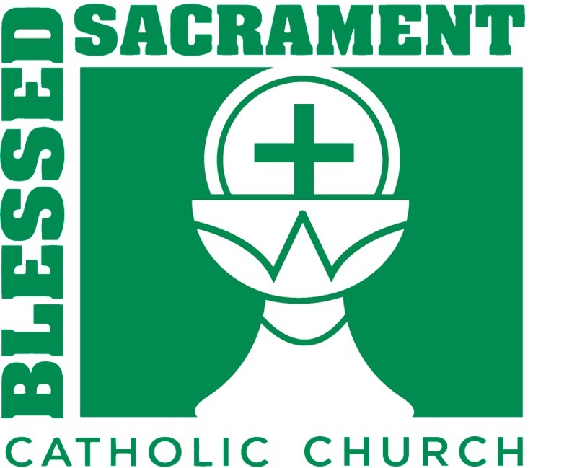

Welcome 2.0
Men’s Retreat
Registration Form
March 30-31, 2019
April 7- 8, 2018

The Welcome Retreat is two days and involves an overnight stay on the Blessed Sacrament Campus.
You will just need to bring your air mattress/cot, bedding, toiletry items and comfortable clothing.

Today’s date:
Men’s Retreat: March 30-31, 2019
Name: _______________________________
Address: ______________________________
______________________________
Cell Phone: ____________________________
Email Address: _________________________

Please let us know of any special needs you have.
Dietary: ________________ Vision/Hearing________________
Mobility: _______________ Sleeping: _____________________
Other: ______________________________________________
____________________________________________________
____________________________________________________

Emergency Contact Information:
Name/Relationship: ____________________
Best Phone Number: ___________________
Email Address: ________________________
We want to pray for your family & friends as well as have them pray for you as you prepare for your retreat. Please list individuals that we may reach out to. You may use the back for additional names. Name/Relationship/Phone/Email
_______________________________________________________________________________________________________________________________________________________________________________________________________________________________________________________________
Please submit this information as soon as possible but no later than March 24, 2018
You may submit your registration in the following ways:
Drop the registration off at the Parish Office
Email to moyerheath@aol.com

For More Detailed Information Contact: Heath Moyer at 912 441-9446 cell

